The Complete Bullwhip Buyer’s Guide — From a Craftsman’s Hands to Yours
(Written by a maker, explained for every reader, structured for those who want to learn.)

🪶 Introduction
I’ve spent years cutting leather, shaping strands, and hand-braiding whips that tell their own story.
At LeatherBond, every whip is made by hand — not mass-produced. Each braid carries hours of patience, skill, and care.
Whether you’re looking for a leather bullwhip, a professional bull whip, or even the Indiana Jones whip, this guide will help you choose the right one. I’ll explain what makes each type special — from a kangaroo hide bullwhip to a paracord bullwhip, from 8 ft bullwhip to a short snake whips — in plain, honest language.
This isn’t written by a marketing team; it’s written by a maker who has handmade and cracked thousands of whips and tested every design himself.
PART 1

Rope Core Bullwhips for Sale - Budget Leather & paracord bullwhip for Sale for Beginners – Best Whips for Beginners.
Affordable Beginner Bullwhips – Perfect for Hobbyists & Costumes:
Our rope-core leather whip is an ideal bullwhip for beginners, casual whip crackers and cosplay enthusiasts. These budget rope core whip for sale start from $25 to $50 depending on 3ft, 4ft, 6ft, 8ft, 10ft, 12ft, 14ft & 16ft lengths. We also offer rope core Indiana Jones whip without breaking the bank. Each braided whip is handmade with either cowhide leather or nylon / paracord on the outside and a flexible rope at the core. This lighter construction makes them easier to learn the basic crack of whip and whip cracking hobby use, while still producing that satisfying whip crack sound.
- Rope Core, Leather braided Bullwhip for sale:
Hand braided cowhide leather on a rope core, these whips have the classic look and feel of leather. Entry-level bullwhip for practice or as a realistic Indiana Jones bullwhip costume prop. The rope core keeps cost low, though it results in a lighter, less dense whip compared to professional models. (Note: Lower quality whips for sale often use rope cores or even duct tape, lacking the weight and durability of leather-core bull whips. Still, our rope-core bullwhips are handmade with attention to detail, making them well tapered and superior to generic cheap whips.
- Rope Core, paracord bullwhip for sale: For those who want an even more low-maintenance bullwhip, our rope-core nylon bullwhip is an excellent choice. Hand braided from durable paracord, they’re resistant to weather and don’t require regular conditioning. Nylon bullwhips come in vibrant colors and are popular for beginners’ practice and sporting tricks due to their flexibility. Despite the budget price whip, we build these with quality nylon braiding so you can learn whip cracking without the whip fraying apart (a common issue with many ultra-cheap Amazon whips).
Uses:
Both types of rope-core bullwhips are lightweight whips perfect for learning basic techniques, performing Halloween or cosplay scenes, or as a starter whip for kids (with supervision) and adults alike. They are not intended for heavy-duty ranch work or high-precision sport cracking, but they’re loads of fun for casual whip cracking practice in the backyard or at events. Here is the video of whip cracking enthusiast who is practicing Leather Bond Rope Core Whips:
https://www.youtube.com/watch?v=GrQ4vb6kIgg
Caption: A whip enthusiast practicing bullwhip cracking outdoors. Budget-friendly rope core whips are great for learning basic cracks safely.

PART 2:
- Types of Whips
Bullwhip vs Stock whip vs Snake Whip:

Bullwhip: A bullwhip has an integrated rigid handle from 6 to 2 inches long and is measured along its entire braided length. We have 5 types of following whips.

Bullwhips for Sale: These are the Cowhide Leather rope core, leather whips (budget friendly). (Shop Now)

Leather Whip: We have cowhide leather whip with leather belly and bolster construction. For more details click here OR (Shop Now)

Bull Whip: We have Kangaroo hide bullwhip with leather belly and bolster construction. For more details click here OR (Shop Now)

Paracord Whip: These hybrid whips are hand-braided with paracord but have leather belly and bolster construction. For more details click here OR (Shop Now)
- Whips for Sale: This a nylon bullwhip with rope core light weight and budget friendly. (Shop Now)

Australian Stock Whip: A stock whip has a separate, detachable thong with a keeper and a long 18 to 24 inches handle, handle is not measured in its length), See the detail of Stock Whips here click here OR (Shop Now).
    - Snake Whip: A snake whip, which is similar to a bullwhip but has no rigid handle, making it fully flexible and packable. (See the detail of Snake Whip here OR (Shop Now).

Part 3
- Anatomy of a Whip / Parts of a Bullwhip
A quality bullwhip has several key parts / Anatomy of a BullWhip / Key Parts of a Whip
  - Wrist Loop: This is an optional part of a whip. Wrist loop easily fit over your wrist for security and to prevent loss.
  - Handle: Rigid grip, usually 6–12 inches, often braided or wrapped.
  - Heel Knot/Base Knot: The knob at the end of the handle that anchors the braid.
  - Transition Knot. This knot is made on the transition point from the handle to thong.
  - Thong: The main braided body of the whip.
  - Fall Hitch: This is the end of the braiding, where the fall is attached. This hitch is crucial because the fall takes the extreme stress of cracking and needs to be replaced after some time. If you want and instructional video to replace a fall of the whip, contact us.
  - Fall: A single strip of leather or cord that connects the thong to the tip.
  - Cracker/Popper: The replaceable end tip of the whip that actually makes the sound. Usually made from nylon braided thread
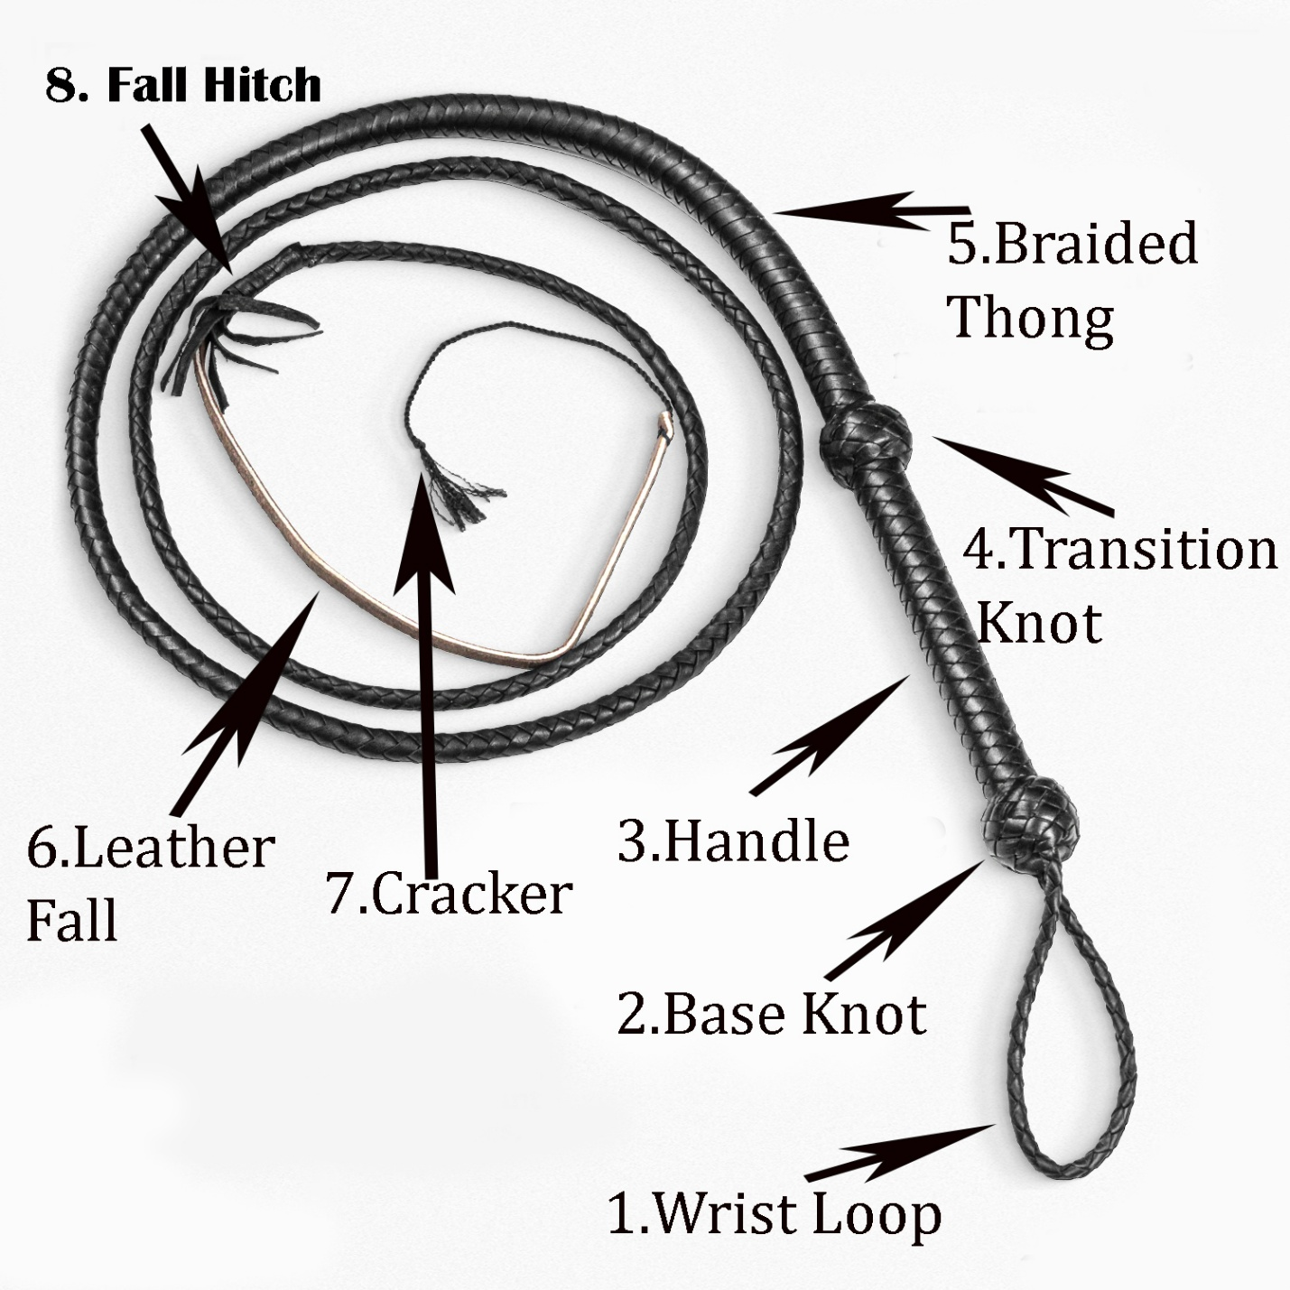

Part 4

FAQ –

What is a Bullwhip?
A bull whip is a single-tailed whip with a rigid small handle about 8 to 12 inches long and a braided thong that tapers down to a thin leather strip called the fall, finished with a replaceable cracker. When swung, the whip sends a traveling loop of energy to the tip. That snap you hear isn’t leather slapping — it’s a miniature sonic boom.

How Does a Whip Work?

The shape of the whip allows energy to move from the handle to the braid with ease, speeding up the tip. The whip becomes lighter and thinner as the loop moves, which forces the tip to move more quickly until it breaks the sound barrier. Because of this, a tiny flick can produce a sharp cracking sound.

What is the best bullwhip for a beginner?
For newcomers, a shorter, affordable whip is usually best. Experts often recommend a Rope core Cowhide Hide Bullwhips for Sale / Nylon Whips for sale around 6ft or 8 ft as an ideal beginner whip. Our rope-core beginner whip fits this advice perfectly – it’s low cost and 6 ft, 8 ft, 10 ft, 12 ft, 14 ft and 16 ft long, making it easy to handle while you learn. In general, the best bullwhip for beginners is one that is not too long 6ft or 8ft are the easiest, not too heavy, and doesn’t require complicated upkeep, so you can focus on bullwhip mastering technique. That’s why our beginner bullwhips (either leather or nylon, rope-core) are popular – you can start cracking without a big investment.

How to choose the Right Length of a bull whip?

Whip length makes a huge difference in control and performance:
- 6–8 ft : Best for beginners. Easier to handle, safer in smaller spaces.
- 10–12 ft: More reach and louder cracks, ideal for experienced handlers.
- 14–16 ft: Specialist territory. Impressive sound and flow, but requires skill and space.
- How Fast Is a Bullwhip?
The tip of a bullwhip can travel over 700 mph (1,126 km/h) — faster than the speed of sound. That’s why the crack sounds like a booming sound.
- How much does a whip costs?
Rope core bullwhips costs approx. $25–$50 depending on 4ft, 6ft, 8ft, 10ft, 12ft, 14ft &16ft lengths offer an affordable whip experience without breaking the bank.
- Are nylon bullwhips good for beginners?
Absolutely, our nylon whips for sale are highly recommended for first-timers. The synthetic material is flexible and can take hundreds of practice cracks without drying out or needing special care. Nylon whip is also usually cheaper, so you won’t be as worried about scuffing it during practice. Many whip makers note that a well-made paracord bull whip is versatile and perfect for new handlers. Just remember to practice in a safe open area, since even a beginner whip can crack loudly and requires space for the lash to travel.
- What’s the difference between rope core and leather core real bullwhips?
OR
What are the whips made of?
The core is the foundation of the whip. Rope-core bullwhips (like the ones on this page) use a braided rope or core as the inner core. This makes them lighter and easier to produce, which keeps the bullwhip price low. However, a rope core doesn’t add weight to the thong, so rope-core whips tend to be less dense and have less momentum in the swing.
In contrast, a professional bull whip with a core made of rolled leather plus multiple internal braided layers (braided bellies) and (leather bolsters). This yields a heavier, more solid whip that cracks louder and performs more consistently. In short, rope-core whips are fantastic for casual use and learning, but a leather-core whip is preferred for high performance and longevity. (We’ll dive more into leather core whips in the next section! Click here)

